**NEW YEAR TALKABOUT**

Welcome once again to your newsletter in which we hope to continue to inform, educate, and entertain you.

Amazingly, we are in 2017 already. The flu clinics were again a great success. If you are eligible for a flu jag but missed the clinics please phone reception for an appointment, there are still flu vaccines available. We would like to say a sincere thank you to all those patients who offered their time to feedback their thoughts during the flu clinic. The results are below.

If you sometimes find it difficult to get an appointment with your GP, the local pharmacies are able to offer advice and treatment for ailments such as conjunctivitis, urinary tract infections, impetigo, COPD, coughs, colds, hay fever, verrucas, and blood pressure checks. They also offer a Stop Smoking Service. If the pharmacy is unable to give you something to help, they will still give you advice about where to go.

Doctors and staff would like to extend their thanks for all the Christmas gifts handed in, these are very much appreciated and enjoyed! We hope you enjoy this New Year issue of Talkabout and please remember any comments or suggestions you have for future issues will all be gratefully accepted and considered.

Happy New Year to you all!

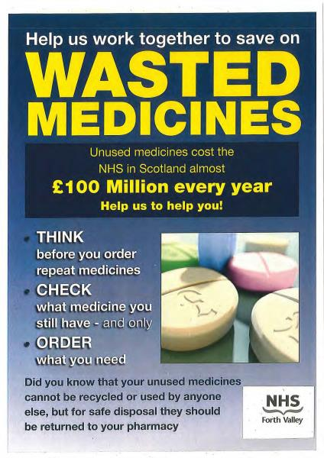

**If you don’t use it,**

**we can’t reuse it!**

Wasted medicines cost NHS Forth Valley approximately £1.2m every year. When medicines leave the pharmacy they cannot be recycled, reused by anyone else or sent abroad. Those which are wasted are all destroyed.

Wasted medicines can arise when your GP changes or stops a medicine but you can help us to reduce wasted medicines in other ways.

Before you order a prescription have a look in your medicine cabinet to see what you have and only order what you need. If you have stopped taking a medicine let your GP or Pharmacist know.

Unused & unwanted medicines should **always** be returned to the pharmacy for safe disposal.

**Never** put medicines in the bin or flush them down the toilet. To help the NHS reduce wasted medicines, **always:**

**THINK**before you order

**CHECK** what you already have

**ORDER** only what you need.

**LOCAL PHARMACIES AND USEFUL NUMBERS**

What to do if... **you have a 'flu-like' illness.**

**What are the symptoms?**

High temperature; tiredness & weakness; headache; general aches & pains; dry chesty cough.

**What's the difference between a cold and flu?**

Often the symptoms are similar, but flu is more severe and can make you feel exhausted. Flu comes on quickly and can make your whole body ache. Colds tend to come on gradually and mainly affect your nose and throat.

**What can I do if I think I have flu?**

If you are normally fit and healthy it's fine to treat your flu at home. Keep warm, eat if you feel like it and drink plenty fluids. You can take Paracetamol or Ibuprofen. Be careful not to spread your germs, put your tissues straight in the bin and wash your hands.

If you are 65 or over, have other medical problems such as heart, lung, kidney, liver or neurological disease, have a weakened immune system or have any symptoms that concern you such as chest pain, shortness of breath or you are pregnant, please contact us. In some extreme cases, and if there has been a declared outbreak of 'flu in the Forth Valley area, antiviral medications may be helpful. Generally, simple treatment is all that is required and is best.

**If you are in the 'at risk' groups mentioned above and have not yet had a flu jag please make an appointment.**

**PATIENT PARTICIPATION GROUP**

**PRACTICE NEWS**

**T A Mack**

Tillicoultry

01259 750261

**Well**

Tillicoultry

01259 750349

**Well**

Alloa

01259 218039

**Lloyds**

Dollar

01259 742536

**Lloyds**

Alloa

01259 218979

**Lindsay & Gilmour**

Sauchie

01259 723155

**R & J Marshall**

Alva

01259 760389

**R & J Marshall**

Menstrie

01259 769300

**Boots**

Tullibody

01259 722864

**Boots**

Alloa

01259 723246

**NHS 24**

**111**

**Dental Helpline**

0844 800 6886

**Midwife Booking**

8.30am–12noon

01324 567146

**Forth Valley Royal Hospital**

01324 566000

**Clackmannanshire Community Hospital**

01259 215333

**Patient Contact Information**

Please check with the receptionist that we have the correct contact details for yourself and your next of kin.

**Online Prescriptions & Appointments**

Ask reception staff for an online pin code and register at [www.patientaccess.co.uk](http://www.patientaccess.co.uk).

You can then book appointments and order repeat prescriptions online.

**Appointment System**

Routine appointments can be booked in advance. If however you feel you cannot wait until then you can ask for an on the day appointment where you will be offered a telephone consultation.

**Patient Survey**

* 175 patients between the ages of 48 & 91 participated (89 female, 86 male) - roughly 2% of the patient population.
* Both groups identified that the friendliness and efficiency of staff was excellent and the level of clinical care was rated to be caring and extremely supportive.
* One of the concerns raised was the continuity of doctor. Patients would like to see a particular issue through with the same doctor, which is sometimes difficult.
* There were mixed reviews on Triage, most were pleased they could speak to a doctor on the day they needed to, to put their minds at rest. Some preferred drop-in but agreed if Triage could be extended through the day it would be similar to drop-in.
* Many comments were in relation to the waiting area and felt it could be cheered up.
* Overall the message from all those who participated was that the service offered by the staff was excellent and the clinical care was caring and supportive.

**Wound dressings,**

**suture removal,**

**ear Syringing**

**Blood pressure checks,**

**phlebotomy (taking**

**blood), urine tests,**

**height/weight checks.**

**Referrals can be done by the Practice Nurse to the NHS Forth Valley Stop Smoking Service.**

**The support sessions will be in the practice or phone NHS Forth Valley Stop Smoking Service 01786 433293**

**A drop in Stop Smoking Service is available at Clackmannan Community Health Care Centre on Tuesday 4pm-6pm or contact your local pharmacy**

**Physiotherapy**

**For backache, muscle and joint problems there is a wealth of information at** [**http://www.nhsinform.co.uk/msk/**](http://www.nhsinform.co.uk/msk/)

**You can self-refer for physiotherapy treatment by phoning 0800 917 9390**

**...smoking cessation, dry skin, nappy rash, small patches of impetigo, abrasions,**

**bruises, insect bites & sunburn, thrush, head lice, piles, pain relief, emergency contraception, urine infections (adults 18-65)**

**Dry, red, sore, watery, sticky or itchy**

**eyes or eyelids. Squints in children,**

**flashing lights, headaches when**

**reading or watching TV, cysts and styes, conjunctivitis, corneal ulcers or abrasions, reduced or double vision, blepharitis (inflammation of the edge of eyelids)**

**Optician**

**Smoking**

**Podiatry**

**NHS Podiatry is only**

**available in very specific circumstances , via GP referral**

**Health Care Assistant**

**Practice Nurse**

**Cervical screening tests , travel advice & vaccinations**

**Chronic Disease Management of the following:**

**Asthma, atrial fibrillation, cardiovascular disease, COPD,**

**diabetes, heart disease & heart failure, hypertension, kidney**

**disease, peripheral arterial disease, stroke.**

**Referral to Forth Valley Stop Smoking Service**

**Treatment Room**

**Dentist**

**Any condition involving your mouth or teeth**

**Reception**

**Make, cancel and change appointments,**

**general enquiries, housecalls.**

**Pharmacy**

**Coughs & colds, conjunctivitis (over the**

**age of 1), sore throats & earache for**

**less than 3 days, verrucas, constipation, hay fever, mouth ulcers, cold sores, blood pressure checks...**

**ALTERNATIVES TO GP FOR ADVICE AND ASSESSMENT**

**Public Holidays 2017**

Monday 2 January

Tuesday 3 January

Good Friday 14 April

Easter Monday 17 April

Monday 1 May

Monday 12 June

Monday 4 September

Monday 9 October

Monday 25 December

Tuesday 26 December

**Create Training Days**

(doors close at 12.30pm)

Thursday 16 February 2017

Wednesday 29 March 2017

If you have an urgent medical issue when the Health Centre is closed please contact NHS24 by telephoning 111

**Staff Meetings**

The surgery will close from 12.30-1.00pm on the first Wednesday or Thursday of every month.

**Surgery Opening Times**

Monday–Friday

8.00am–6.00pm

**Prescription Line**

9.00am–12noon

**Appointments & Prescriptions**

01259 750531

**Health Visitors**

01259 750350

**District Nurses**

01259 752261

**Website**

www.tillicoultrymedicalpractice.co.uk

**NOROVIRUS**

Norovirus causes diarrhoea and vomiting and is one of the most common stomach bugs in the UK. It's also called the "winter vomiting bug" because it's more common in winter, although you can catch it at any time of the year. It can be very unpleasant but it usually clears up by itself in a few days. You can normally look after yourself or your child at home. **Try to avoid going to your GP, as norovirus can spread to others very easily.** Call your GP or [NHS 111](http://www.nhs.uk/NHSEngland/AboutNHSservices/Emergencyandurgentcareservices/Pages/NHS-111.aspx) if you're concerned or need any advice. For full details of the symptoms of Norovirus and what to do visit

<https://www.nhsinform.scot/illnesses-and-conditions/infections/norovirus>



As we start the New Year, many of us make New Year resolutions to get fitter and start eating healthier. There are many different exercise classes and groups available in the area for all ages, many of which are free. At the same time as providing exercise, some groups are a great way to meet like-minded people and make new friends. If you want to get out and about, one such group is the Wee County Walkers who cater for all levels of ability and is a great way to meet new people. Taking just 30 minutes of exercise a day and eating a healthy diet can help towards a fitter healthier you in 2017!

Here is a healthy eating recipe to get you started:

***Grilled Salmon with Avocado*** *(Healthy Fats!) Serves 1*

*Drizzle Olive Oil 240g Salmon fillet (skin on)*

*2 tbsp Pumpkin Seeds 1 Avocado (peeled & de-stoned)*

*1/4 Red Onion 2 tsp Sesame Oil*

*40g Feta (drained) 1 tbsp of Chopped Coriander*

*Handful Watercress Juice of 1 Lime (optional)*

*Drizzle olive oil over skin side of the salmon and place on the grill pan or baking tray. Cook for 6 minutes, flip, then cook on the other side for 4 minutes. Leave the salmon under the grill on low to keep warm.*

*Tip the pumpkin seeds into a dry pan and toast for two minutes. Season with sea salt.*

*Using a fork, break up the avocado in a bowl and add the onion, coriander and sesame oil mix until the ingredients are combined. Remove the skin from the salmon, pile up the guacamole and scatter the slices of feta over the salmon. Finish with a topping of pumpkin seeds, watercress and a squeeze of lime.*

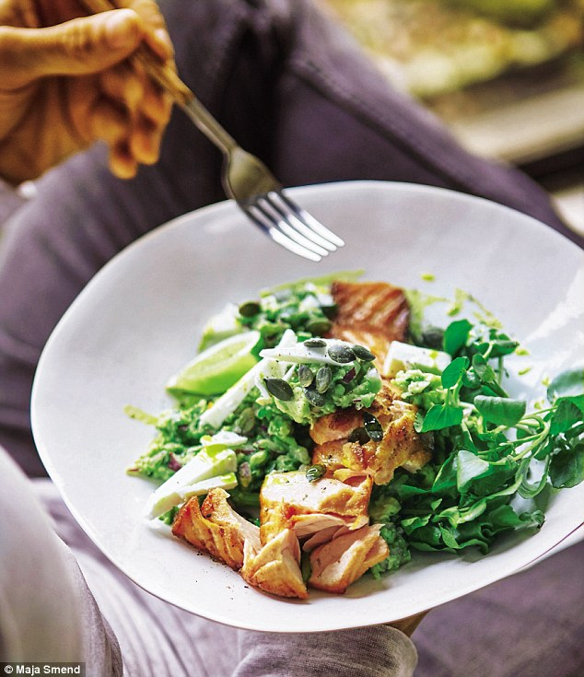

If you would like to do something rewarding in the new year there are many opportunities for voluntary work. Volunteer Scotland has more information on what is available and “Contact the Elderly” (0800 716 543) is one organisation dedicated to support those who may feel alone and who may benefit from some company. Anyone can volunteer from the age of 12-92!

If however, you feel you have no one to turn to yourself, the Samaritans are there to help and can be called anonymously and at no cost on 116 123.